Better Bioinformatics Through Usability Analysis
Supplementary Information

Davide Bolchini, Anthony Finkelstein, Vito Perrone and Sylvia Nagl
Contacts: davide.bolchini@lu.unisi.ch

Abstract
In this supplementary information, we present additional data concerning the two usability studies that have been carried out to identify and characterize a first set of usability problems of web-based bioinformatics resources. We provide a more complete set of quantitative results from the usability inspection of the CATH website (section 1), including an explanation of the inspection process, and summary data on the usability problems found. Section 2 offers an overview of the quantitative results from the user testing focussing on search tasks of three web bioinformatics website, namely BIOCARTA, NCBI and SwissProt.

- Usability Inspection on CATH

  - The process of usability inspection with MILE+

As preparatory activity for the inspection of CATH, it was important to characterize the “object” of the usability analysis. To this end, we have developed a synopsis of the information architecture and navigation capabilities of the application using the IDM method [Bolchini et al., 2006). The map (figure 1) represents the core content topics available to the user, the main navigation connections between these topics and strategies for accessing them. For a detailed reference on IDM concepts and visual notation see [Bolchini et al., 2006). Having a clear abstraction of the information architecture has a number of advantage for usability analysis, including the ability to master the complexity of the information architecture at a glance (and at the appropriate level of detail), and to have a reference map for the ongoing inspection.
For CATH, the high-level modeling of the information architecture resulted in the identification of 4 core content topics: protein domain, chain, PDB description, and homologous superfamily. Each topic presents multiple instances. For example, at the time of the inspection, there were 93,885 protein domains, 63,453 chains, 30,028 PDBs, and 1,459 superfamilies. These topics represent the key target content of the user interaction. To access these topics, CATH offers multiple navigation structures. To access and browse protein domains, CATH provides a primary classification of proteins in 4 main categories (Class 1, Class 2, Class 3 and Class 4). Each main category in turns contains an 8-level hierarchical structure of protein classification (Architecture, Topology, Homologous Superfamily, and 4 further levels related to the sequence similarity criteria). Once the user (eventually) gets through the hierarchy and reaches the details of a protein domain, s/he can traverse navigation connections to related content: to the corresponding chain or to the corresponding PDB. The access structures to the homologous superfamilies are organised as a full index of all the superfamilies and a summary table. Once at the details of a superfamily, the user can navigate directly to the corresponding superfamily level in the protein classification hierarchy. At the highest level of these access structures there is additional introductory information explaining the purpose and the criteria for the classification of the content.

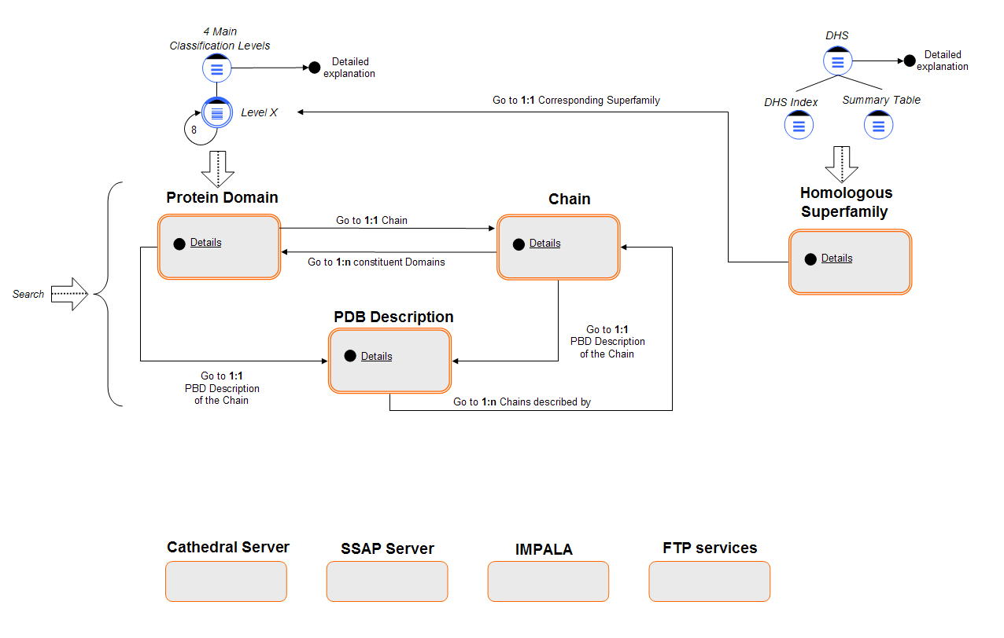
Figure 1. High-level information architecture map for CATH.

A search engine provides keyword-based query access to the topics and more static, ancillary content and upload services are available (upload servers, IMPALA, or FTP services).
These elements, which support the core of the user experience with the applications, constitute the key objects of investigation for the usability inspection and represent the context in which we frame the usability problems.

During the execution of the usability inspection, there are various strategies to employ the set of 82 heuristics offered by MILE+. The choice of the strategy depends on a number of factors including the time available to the inspectors, their experience in usability evaluation, their knowledge of the application domain, and the size of the application (Triacca, 2005).
We can identify 3 main strategies:
- “Leopard's spots” evaluation
- Feature-driven evaluation
- Scenario-driven evaluation

Leopard’s spots evaluation or “critical exploration”
This type of evaluation is useful when the application is small or for focussing on specific site sections (to quickly narrow the scope of the analysis). It consists in exploring in depth a section of the application and then randomly moving to other sections, trying to put the application to test with the heuristics at hand. The initial focus is typical on interface and navigation-related aspects; however, technological problems may emerge during exploration, as well as content-related issues. This inspection approach may be called Leopard’s spots evaluation because it almost randomly starts from a specific point in the application and then the analysis naturally expands to include other parts on the basis of the criticalities identified. For example, with the MILE+ heuristics at hand, in a preliminary navigation within the main sections of the CATH website, an inconsistency of the presence of the main navigation bar elements (technically called “landmarks”) has been spotted. Then, a specific analysis of these landmarks has been carried out and the problem has been identified and characterized in its various aspects thanks to the MILE+ heuristics. Later on, all other landmarks in other sections have been checked for consistency.
This strategy for MILE+ inspection works very well for a preliminary and quick check-up of the website, and if the inspectors has long-standing usability analysis experience (although not necessarily in the specific application domain) and know the heuristics well.

Feature-driven evaluation
Once inspectors have acquired enough confidence with the application, a more systematic inspection can start. Feature-driven inspection consists in checking each design dimension individually (navigation, content, interface and technology) according to MILE+ heuristics, and organize the inspection process around the applicable features to which heuristics are associated (e.g. guided tour navigation, tree navigation, page layout grid, etc.). This strategy is the most expensive in terms of time but the most rewarding in terms of number of types of problems found. Once a type of problem is found according to a heuristics, the inspector can verify how many instances of that problem occur, to get an additional indicator about the severity of the problem in terms of its pervasiveness in the application. In CATH for example, the usability issues associated with the guided tour navigation feature around which the Dictionary of Homologous Superfamily is organized have been spotted through the navigation heuristics. Then, once identified the rigidity of this specific guided tour, other occurrences of this problem in other access structures have been hunted for.

Scenario-driven evaluation
Scenarios can be used not only during user testing (as described in the paper), but also as drivers for inspection. Building scenarios for usability inspection means identifying a relevant user profile for the web application and envision the way in which s/he may use it in a typical situation to accomplish one or more tasks. To circumscribe the scope of the inspection, a scenario typically focuses on selected sections of the application. As inspectors try to execute the scenarios, usability problems may emerge as obstacles to the successful accomplishment of the scenario.
For example, when focussing on the navigation of the hierarchical (tree-based) classification of protein domains, inspectors tried to reach the details of a protein domain starting from the highest level (class), assuming – after discussion with CATH designers – that is a typical exploratory task to be supported for CATH users. Problems related to the inefficiency of the navigation mechanism in the hierarchy emerged in this analysis process. At each level of the hierarchy, for example, it is shown the total number of sons for that branch. As a matter of fact, the sub-branches at each level are very unbalanced in terms of population. The system, however, does not provide a way to see how all the sons are distributed over the next sub-branches. Therefore, the user cannot be aware of the fact that some sub-branches are very populated (e.g. 100 sons), while others are practically empty (1 or 2 sons). The only way to discover it is by navigating in each sub-branches (going up and down in the hierarchy), which makes the whole exploratory process much more cumbersome and inefficient.

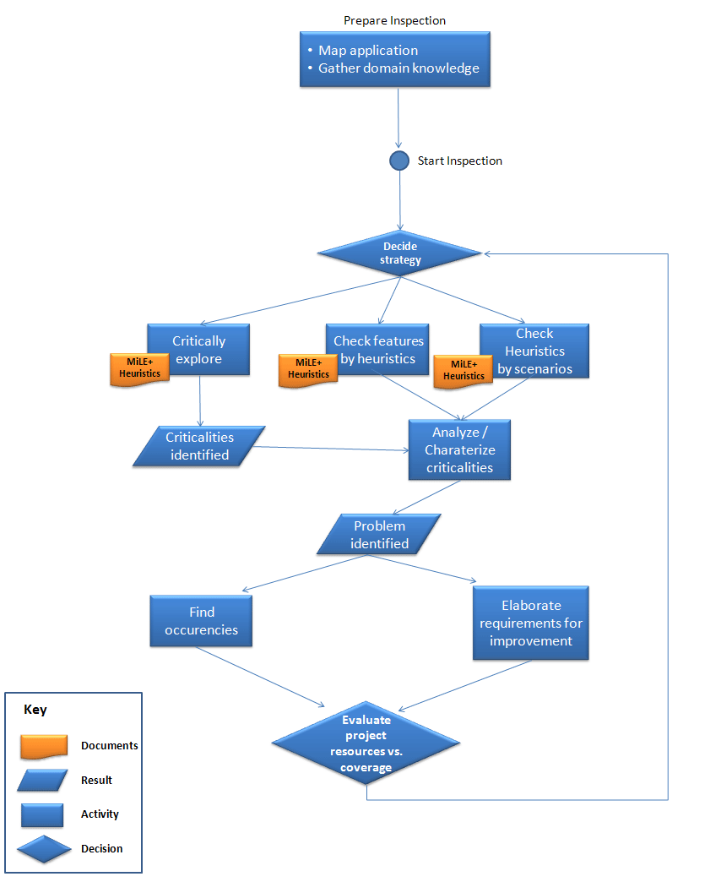
Figure 2. An overview of the usability inspection process with MILE+.

The three strategies can be used in parallel and in a blended way (see Figure 2). For the usability inspection of CATH the inspector started from a preliminary Leopard’s spot evaluation, given an initial low confidence and knowledge in the specific CATH domain. As usability issues began to emerge, a feature-driven evaluation was more systematically carried out starting from the critical areas identified. Scenario-driven evaluation was then used for specific application areas, such as the navigation of the hierarchical protein classification, where plausible and typical user’s tasks could be easily anticipated, given the nature of the information architecture.

  - Summary of Usability Problems

The types of usability problems discovered and addressed during usability analysis of CATH mainly concern navigation and interface design. It is interesting to note that the actual occurrences of these problems often reach a very high number because of the database-driven nature of the web application, as it automatically replicates the same problem for every data instance of the same type. For example, a wrong navigation link in each superfamily overview page accounts for one problem types, but it will have as many instances as many superfamilies are present in the repository.
The total number of usability problems found and characterized during inspection are organized by design dimensions (Table 1) and listed according to the relevant MILE+ heuristics (table 2).

 | Number of problem types | Number of problem occurrences
Content | 1 | 1
Navigation | 10 | >10’000
Interface design | 6 | 16
Technology/Performance | 1 | >4000
Tot. | 18 | >14’000

Table 1. Synopsis of CATH Usability Problems by Design Dimensions.

Heuristics code | Heuristics Name | N. Problem types | N. Problem occurrences | Severity
Content_1 | Accuracy
Content_2 | Currency
Content_3 | Coverage
Content_4 | Objectivity
Content_5 | Authority | 1 | 1 | Medium
Content_6 | Consistency
Content_7 | Text Errors
Content_8 | Multimedia Consistency
Navigation_1 | Topic Segmentation
Navigation_2 | Topic Orientation Clues
Navigation_3 | Topic Accessibility
Navigation_4 | Group Introduction
Navigation_5 | Group Orientation Clues
Navigation_6 | Group Accessibility | 2 | >4000 | High
Navigation_7 | Transition List
Navigation_8 | Transition Orientation Clues
Navigation_9 | Transition Accessibility
Navigation_10 | Landmarks | 2 | 10 | Medium
Navigation_11 | Consistency in Overall Navigation | 2* | 1500 | High
Navigation_12 | Overall Accessibility
Navigation_13 | Multiple Topic Consistency
Navigation_14 | Multiple Topic Orientation
Navigation_15 | Multiple Topic Segmentation
Navigation_16 | Multiple Topic Accessibility
Navigation_17 | Multiple Group Introduction
Navigation_18 | Multiple Group Orientation
Navigation_19 | Multiple Group Accessibility
Navigation_20 | Tree Orientation
Navigation_21 | Tree Backward Navigation | 1 | >4000 | Medium
Navigation_22 | Tree Depth Anticipation | 1 | >500 | High
Navigation_23 | Overall “Go Back”
Navigation_24 | Overall History
Navigation_25 | Guided Tour Orientation
Navigation_26 | Guided Tour Control
Navigation_27 | Guided Tour Strategy | 1* | 1 | High
Navigation_28 | Guided Tour Topology | 1* | 1 | High
Navigation_29 | Index Orientation
Navigation_30 | Index Control
Navigation_31 | Index Strategy
Navigation_32 | Index Topology
Navigation_33 | All-to-All Orientation
Navigation_34 | All-to-All Control
Navigation_35 | All-to-All Strategy
Navigation_36 | All-to-All Topology
Interface_1 | Label Ambiguity | 1 | 1
Interface_2 | Label Overlapping
Interface_3 | Label Genericity/Technicality | 1 | 2
Interface_4 | Information Scent
Interface_5 | Conventionality
Interface_6 | Intuitiveness
Interface_7 | Area Grouping Adequacy
Interface_8 | Position of Importance
Interface_9 | Information Overload
Interface_10 | Scannability
Interface_11 | Page Grouping Adequacy | 1 | 1 | Low
Interface_12 | Classification Adequacy
Interface_13 | Separation Adequacy
Interface_14 | Mental Map
Interface_15 | Visual Identity
Interface_16 | Chromatic Code | 1 | 1 | Low
Interface_17 | Background Contrast | 1 | 1 | Low
Interface_18 | Font Size
Interface_19 | Font Colour
Interface_20 | Font Type
Interface_21 | Text Layout
Interface_22 | Anchor Identity
Interface_23 | Anchor States
Interface_24 | Icon Consistency
Interface_25 | Widgets Consistency
Interface_26 | Position Consistency
Interface_27 | Layout Grid Consistency | 1 | 10 | Medium
Interface_28 | Layout Conventions
Interface_29 | Homepage Redundancy
Interface_30 | Homepage Layout
Interface_31 | Homepage Animations
Tech_1 | Management of User Error
Tech_2 | Scripting Errors | 1 | >4000 | Medium
Tech_3 | Operations Management
Tech_4 | Browser Compatibility
Tech_5 | Plug-ins Required
Tech_6 | Page Download Time
Tech_7 | Media Streaming Optimization

Table 2. Full set of usability problems found in CATH, organized by the 82 MILE+ heuristics. Blank cells refer to heuristics which were not applicable or which did not yield usability problems.

* Usability problems described and discussed in the paper, section 4.

- User Testing

2.1. Characteristics of the user sample

10 subjects have been recruited for the user testing focussing on “search tasks” on three repositories (BioCarta, SwissProt and NCBI). As shown in Table 3, the relevant characteristics of the subjects mainly address their level of background knowledge of bioinformatics and genetics in general, their knowledge (in terms of use) about bioinformatics repositories, the familiarity with the three web applications of the study, as well as the number of years of experience in the field bioinformatics and genetics.

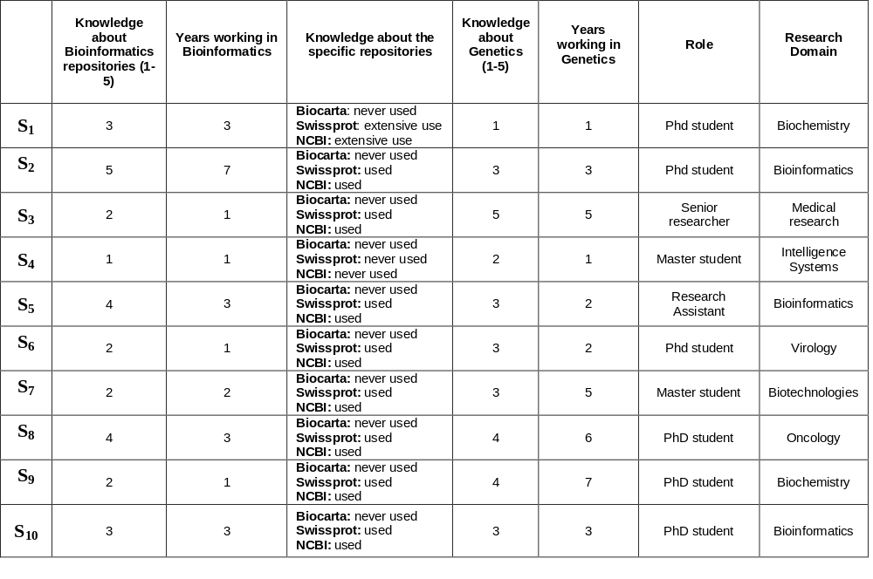
Table 3. The characteristics of the subjects recruited for the user testing.

From the data gathered during recruitment, the set of subjects turned out to be quite well balanced both in terms of bioinformatics knowledge (AV=2.8 in a 1-5 scale, SD=1.22) and number of years of activity in the field of bioinformatics (AV=2.5 in a 1-5 scale, SD=1.84). A slight tendency toward an overall higher level of expertise in genetics knowledge (AV=3.1, SD=1.10) and years of experience (AV=3.5, SD=2.12) is worth noticing.
2.2. User Testing: Summary of Quantitative Results

Table 4 shows the data related to whether or not the user completed the tasks assigned to them. The following scale has been used: 1 denotes successful task completion; 0 indicates “task failed” either because the users gave up or they were obviously out of track after an acceptable time threshold of 15 minutes; 0.5 denotes partial completion (with respect to the content of the task assigned).
Given that the purpose of the search-related usability study was to investigate the nature of the usability problems encountered while searching bioinformatics repositories, the data about the effectiveness in supporting user’s tasks should not be read as a comparative evaluation score between the three web applications (BioCarta, SwissProt and NCBI). The data from the user testing were useful to observe recurrent obstacles users found in searching large repositories and to characterize common criticalities in terms of design assumptions, search interface usability and results displaying. The tasks, therefore, were not designed to systematically put the three applications to test and to compare their relative performances.

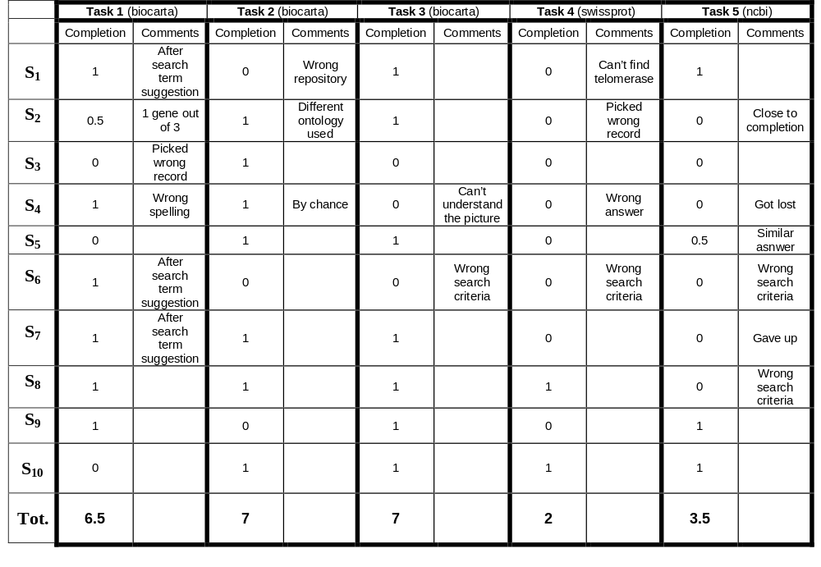
Table 4. Effectiveness in supporting user’s tasks.

Besides the qualitative characterization of the types of usability problems encountered by the users (reported in the paper), the number of query iterations during search task was an interesting finding (Table 5). In our study, a query iteration indicates the number of different search queries performed in the attempt to complete a task. The number of query iteration is one indicator of the level of difficulty in accomplishing the task, which is in turn determined by the design of the system in interaction with the user’s ability to formulate effective queries.

 | Task 1 | Task 2 | Task 3 | Task 4 | Task 5
S₁ | 4 | 3 | n/a | 3 | 3
S₂ | 4 | 3 | 1 | 3 | n/a
S₃ | 4 | 1 | 1 | 2 | 1
S₄ | 3 | 2 | 2 | 2 | 5
S₅ | 4 | n/a | 3 | 1 | 3
S₆ | 5 | 0 | 3 | 3 | 2
S₇ | 4 | 5 | 1 | 3 | 3
S₈ | 3 | 3 | 1 | 3 | 4
S₉ | 2 | n/a | 2 | 6 | 2
S₁₀ | 5 | n/a | 1 | 3 | 3
Average | 3.80 | 2.43 | 1.67 | 2.90 | 2.89
St. Deviation | 0.92 | 1.62 | 0.87 | 1.29 | 1.17

Table 5. Number of search query iterations per task.

Various external factors have influenced these results, however, which cannot be only accounted for the design of the system and the search ability of the user. First of all, the formulation of the task itself may have in some cases tipped off the user by suggesting “ready to use” keywords for the query. These cases might partially account for the low number of query iterations in Task 3. In other cases, the formulation of the task may have suggested terms which are commonly used in the field, but not necessarily supported as they are by the system. In these cases, the user needed to reformulate the query several times to learn the lexicon and syntax supported by the repository search mechanism.

References

Bolchini, D., Paolini, P., Interactive Dialogue Model: a Design Technique for Multi-Channel Applications, IEEE Transactions on Multimedia, 8 (3) 2006, 529-541.

Triacca, L., Inversini, A., Bolchini, D., Evaluating Web Usability with MiLE+, in IEEE Proc. Seventh International Symposium on Web Site Evolution (WSE 2005), Budapest, September 2005, 22-29.

